Hello, Everyone:
December is always a jam-packed month for Exceeding Expectations.
We started with the Tinsel Tri in Hemet.
In 2001, we took a small handful of kids to race. In the 17 years since, EE has been a presence at this event and that presence has been growing steadily. Fifty-one EE kids competed this year and the little ones who, in 2016 did their debut triathlon with the help of Race Angels, this year went solo (not counting a little bit of assistance needed by some in the water). There were many fine EE performances.

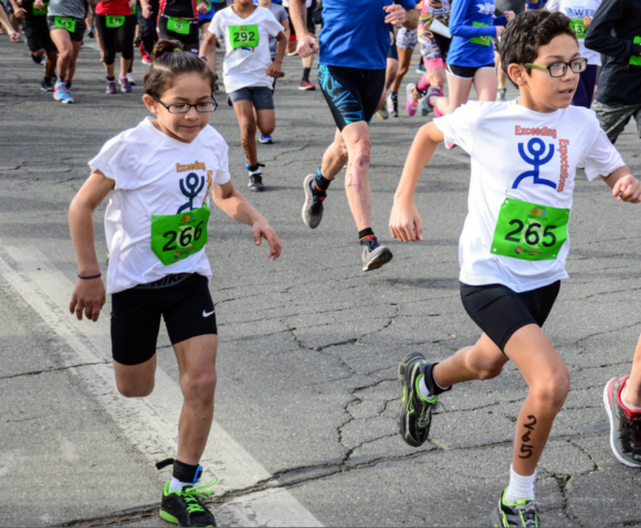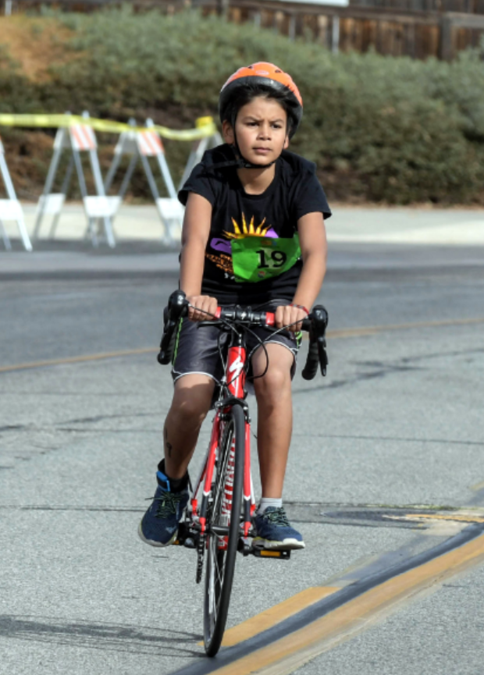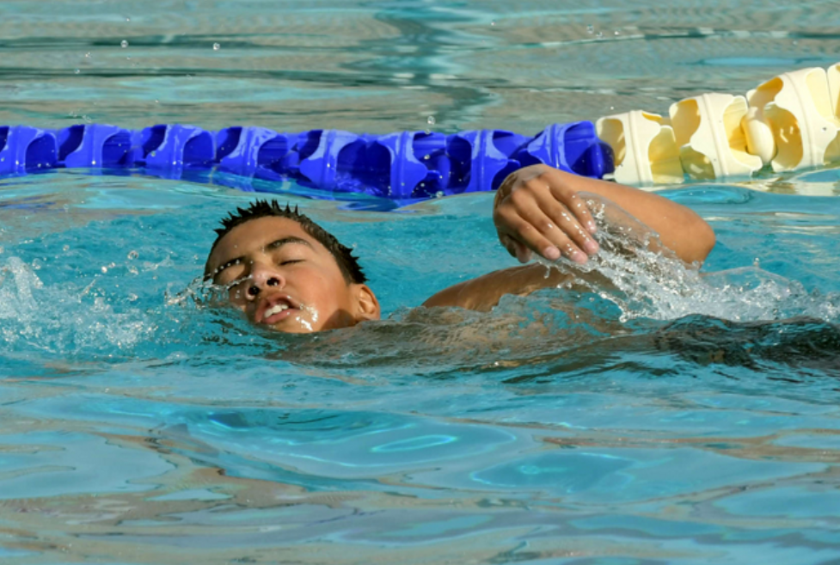
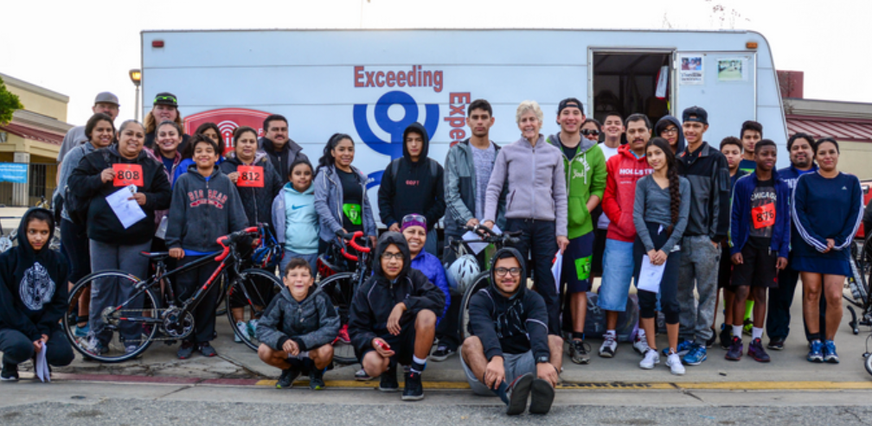

Next on the December agenda was a kids’ favorite – Santa Paws 5K in Palm Springs.
At this event, every racer is provided with a Santa suit, complete with a white flowing beard. Some of our serious runners start the morning declining the suit, fearing it will slow them down. However, by the time the gun goes off, the Santa suits are on. And the extra clothing doesn’t seem to bother these kids. EE did a good job of laying claim to the podium in several age divisions.
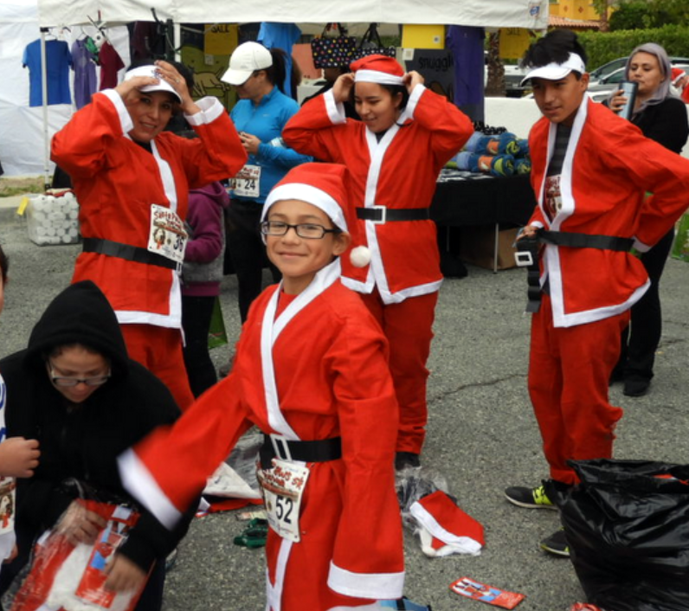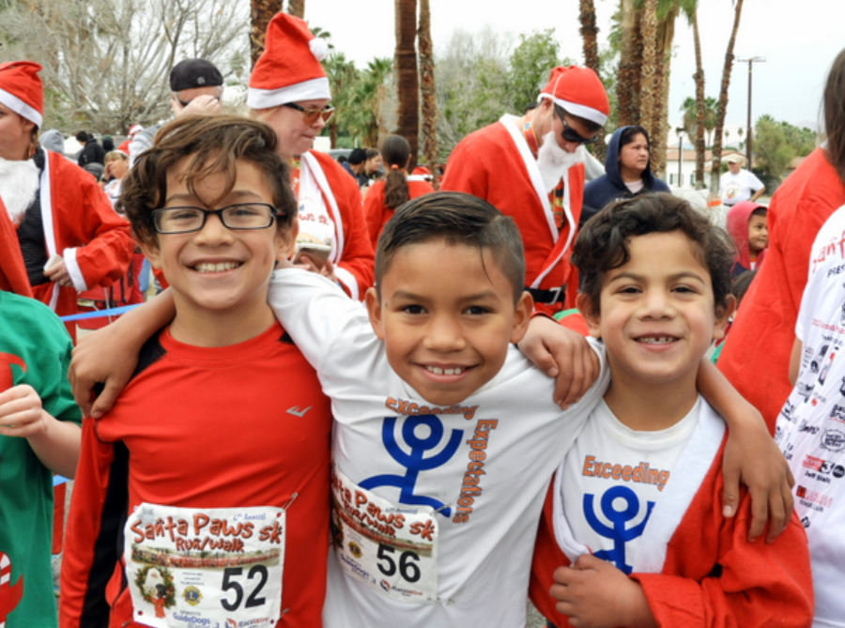

Our annual Awards & Scholarships celebration closes out our year.
As well as celebrating the upcoming holidays, our EE party brings us all together (current and past EE members and families) to recognize this year’s accomplishments and to look forward to goals yet to be met. This event too started many years ago when our group was quite small and we had not much more than dreams of what could be.
Our 2017 party packed a large room at the Drayson Center in Loma Linda. Our EE group included college graduates, current college students, and future high school graduates. In our early years we had no parents attending. This year, we had a large group of parents, some who attend every event with their kids and sometimes even race themselves.
The highlight of this gathering is the presentation of scholarships to kids who are now in college and to others who are soon to graduate from high school.

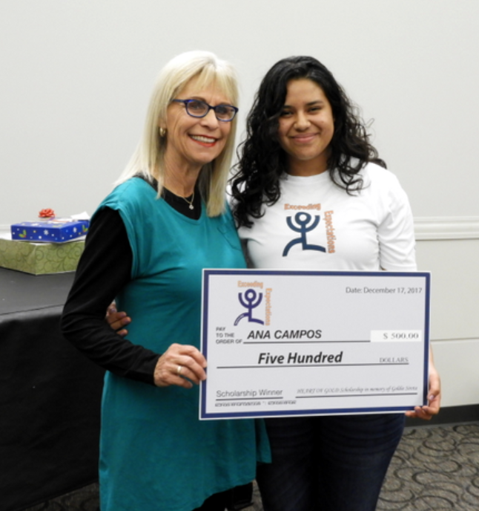

This Awards and Scholarship party is also in honor of each of you who has supported Exceeding Expectations financially or otherwise, sponsoring a single kid or supporting the entire group. Every one of us in EE knows that, without each of you, all we’d have right now would be dreams – instead of all these wonderful accomplishments.
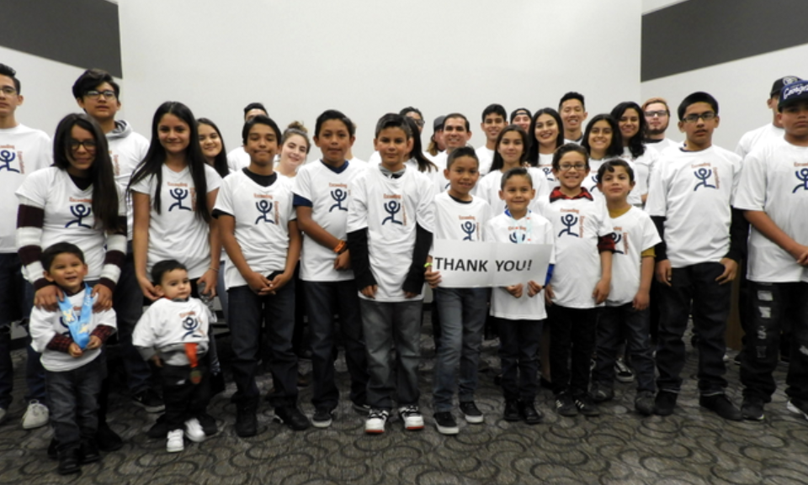
We all thank you very much, and please have a look at the complete photo gallery of the event, here (or http://www.eefoundation.org/ee-2017-awards-scholarships-party/)

-Cherie

